Adding and Deleting Comments

With Google Docs
Comments are a handy way of adding notes to your regular document text and are visible to viewers and collaborators. These can be invaluable for communicating with collaborators about specific parts of the document, as well as making notes about changes you've made or would like to make. When you publish your document as a webpage or print it, the comments will disappear.
Adding Comments
To add a comment to your document, follow these instructions:
- Place the cursor where the comment should appear.
- Click the Insert drop-down menu.
- Select the Comment icon.
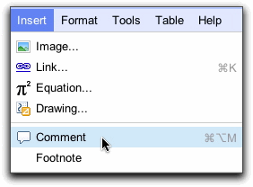
- Type the comment in the box that appears to the right of the document. The User’s username appears by default in the comment.
Deleting Comments
To delete a comment, simply click the trash icon in the comment box.

